CST2120

**Web Application and Databases**

Damien Maujean

M00843707

Coursework 1- Final submission

Table of Contents

1 INTRODUCTION 4

2 THE PAGES 4

2.1 Login & Register Page (index.php) 4

2.2 Game Page (Game.php) 5

2.2.1 Game instruction 5

2.3 Instruction Page (Instruction.php) 6

2.4 Scoreboard Page (Leaderboard.php) 6

3 Conclusion 7

**Table of figure**

Figure 1 - index.php 4

Figure 2 - Game.php 5

Figure 3 - Instruction.php 6

Figure 4 - Leaderboard.php 7

# INTRODUCTION

In this report, we are going to get a brief description of this game website project by describing and explaining the different page, JavaScript, and the game itself. It will firstly cover the login/registration page, follow by the game page and a game description, then follow by the instruction page and finally the scoreboard page.

# THE PAGES

For all the page except the login/registration page, there’s a dynamical welcoming page to display the active username store in the session storage using JavaScript .

## Login & Register Page (index.php)



Figure 1 - index.php

The login page is the first page that appear to the user, without any other button than the login and register to avoid the user continue without login or register. The input validation is all made by JavaScript condition and verification.

For the login the code will iterate in the localstorage the different user’s data and firstly check if the email input by the user correspond, then will check the corresponded for the password, if they both correspond it will keep the email of the active user in the session storage

For the Registration, the code will take iterate in the user’s data in the local storage to check if the email entered by the user doesn’t already exist, then it will check use RegExp to check the validity of the password, if everything corresponds to the wanted condition, it will create the new user’s row of data in the localstorage, and set is email as active in the session storage.

## Game Page (Game.php)

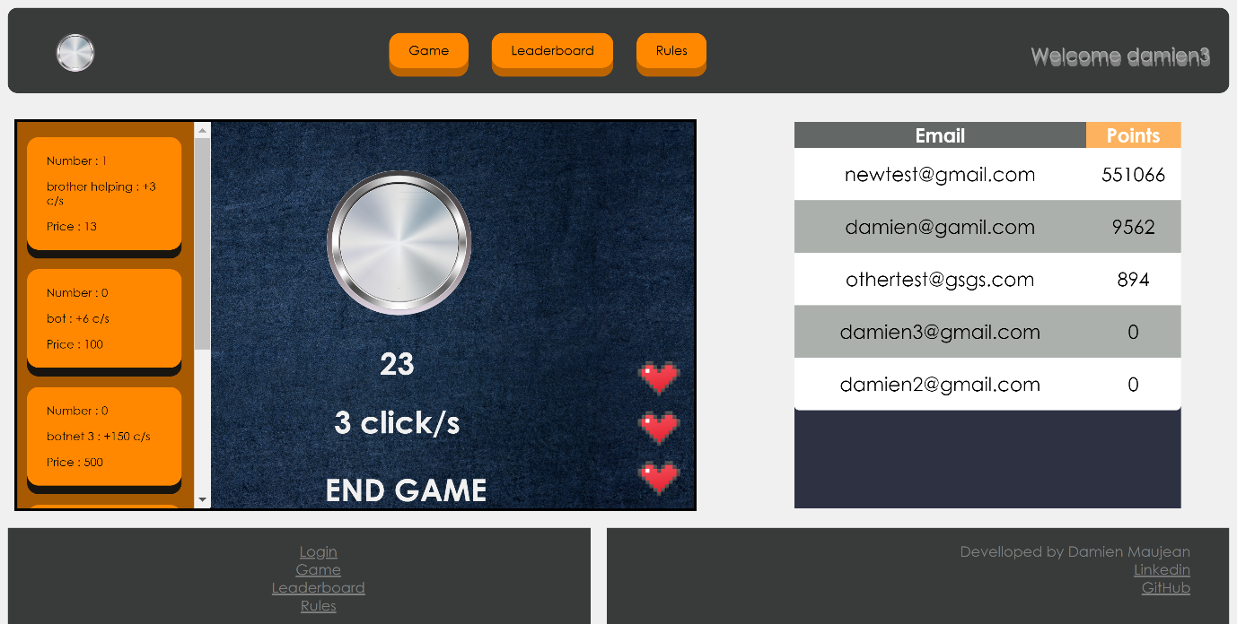

Figure 2 - Game.php

The game page is composed of the same header as the different pages (except the login page), it has an allocate space on the left of the game with some html element on it for the game with some complex JavaScript help with jQuery to generate the game whenever the page is done loading and interacting with the different element when click with some setInterval() function.

When the player loses or end the game, all the data generated during the game are gather and keep in a dictionary, the data gathered are the number of current click (points), the number of click made by the user, the auto click rate and the total number of bonuses.

### Game instruction

To play the clicker, the gameplay is quite simple, to gather point it is only needed to click on the button in the middle of screen. With your points you can buy different bonus on the right of the screen if you have enough click to trade for. You will need to click on the different.

## Instruction Page (Instruction.php)

Figure 3 - Instruction.php

The instruction page contains the different information about the game, is purpose and how to play the game. The only part of JavaScript on this page is the interactive text welcoming the active player on the header of the page.

## Scoreboard Page (Leaderboard.php)

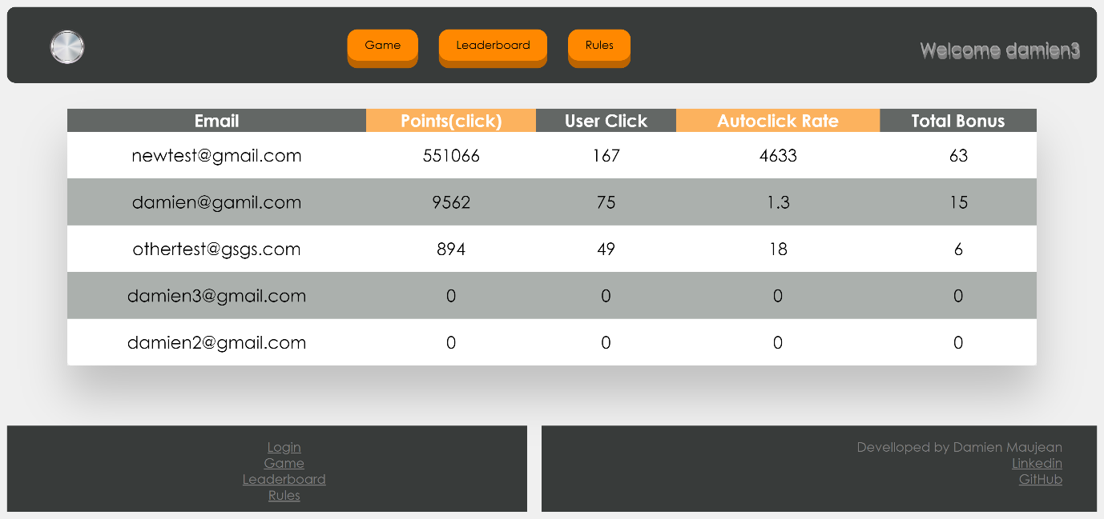

Figure 4 - Leaderboard.php

The Leader board page like the others (except the login/register page) have the header with his interactive welcoming text. The main part of the page is composed of the scoreboard table, which is fill from JavaScript script, it takes all user’s data from the localstorage, sort it and fill the table from the higher to the lower score.

# Conclusion

To conclude this report, I would recommend testing this project using chrome browser (developing browser) for the better experience for this extraordinary website.

The technology used for this project was the use of OOP, a sorting algorithm, jQuery and others.